

**KABARAK UNIVERSITY UNIT: COSF 426**

**CHRISPINE OMONDI OSEWE**

**BSCSF/M/2949/09/18**

**TASK: COMPUTER SECURITY PROJECT**

**TITLE: IMPROVED STUDENT IDENTITY WITH EMAIL AND FINGER-PRINT BIO METRIC AUTHENTICATION.**

**REPORT SUBMITTED TO THE SCHOOL OF SCIENCE, ENGINEERING AND TECHNOLOGY IN PARTIAL FULFILLMENT OF THE REQUIREMENTS FOR THE AWARD OF BACHELOR IN COMPUTER SECURITY AND FORENSICS**

# DECLARATION

I declare that this research project entitled Improved student identity with e-mail and finger-print bio-metric authentication is my original work. The preparation and production of this project was made possible through the technical support and encouragement from my lecturers and peers. My sincere gratitude and appreciation go to them all without their purposeful instructions, it was not possible to come up with this project. I am grateful to all my course mates for their valuable criticism and help in compiling the project. Finally, I wish to heartily acknowledge my family members for their invaluable support throughout the course period financially and even in the developing of this project.

**STUDENT : CHRISPINE OMONDI OSEWE**

**SIGNATURE : --------------------------------------**

**DATE : --------------------**

**SUPERVISOR : MR. JOSHUA MUTAI**

**SIGNATURE : -----------------------------------------**

**DATE : --------------------**

# ACKNOWLEDGMENT

I would like to extend my sincere thanks to my project advisor, Mr. Joshua Mutai, who encouraged and motivated me in developing the project and constant guidance throughout the development of this project proposal. I would also like to extend our sincere gratitude for the academic and technical staff of the Computer Science and Forensic at Kabarak University for their support by providing the required resources. This would also be incomplete without acknowledging the love and support of my parents and friends who always stood by me and continue to do so in my onward journey.

TABLE OF CONTENTS

DECLARATION 2

ACKNOWLEDGMENT 3

ABSTRACT 5

CHAPTER ONE 7

1.1 INTRODUCTION 7

1.2 BACKGROUND OF THE STUDY 7

1.3 STATEMENT OF THE PROBLEM. 8

1.4. OBJECTIVES 9

1.4.1. MAIN OBJECTIVE 9

1.4.2. SPECIFIC OBJECTIVES 9

1.5. SCOPE OF THE STUDY 9

1.6 LIMITATIONS OF THE STUDY 10

CHAPTER 2 10

2.1. LITERATURE REVIEW 10

2.1. INTRODUCTION 10

2.2 IMPLEMENTATION OF IDENTITY CARDS IN COLLEGES 10

2.3 BIO METRIC AUTHENTICATION TECHNOLOGY 11

2.4 FINGERPRINT VERIFICATION SYSTEM. 12

2.5. INTEGRATION OF BOTH STUDENT IDENTITY CARDS AND FINGERPRINT VERIFICATION SYSTEM FOR STUDENT AUTHENTICATION. 12

CHAPTER 3 13

3.1 METHODOLOGY 13

3.1 INTRODUCTION 13

3.2 RESEARCH DESIGN 13

3.2 Research design method. 13

3.3 FLOW DESIGN OF THE WATERFALL 13

3.4 Location of the study 14

3.5 Data collection methods 14

Questionnaires 14

3.7 Data flowchart Diagram. 16

3.8 CONTEXT FLOW DIAGRAM 17

3.9 Level 0 DFD diagram 19

3.1.0 RESEARCH ETHICS 21

CHAPTER FOUR 22

4.0 SYSTEM DEVELOPMENT AND DEPLOYMENT 22

4.1 System description and deployment. 22

4.1.2 Front-end development 22

4.1.3 User Interface design 23

4.1.4 Interface modules 23

4.2 BACK-END DEVELOPMENT 25

4.2.1 Database design 27

4.2.2 Database tables 27

4.2.3 AUTHENTICATION SYSTEM. 28

4.2.4 SYSTEM TESTING 30

4.3 CONCLUSION 30

4.3.2 RECOMMENDATIONS 31

APPENDIX A: Budget 31

APPENDIX B: Project schedule 31

APPENDIX C: REFERENCES 32

# 

# ABSTRACT

learning institutions are rather similar to large organizations with adequately enough members. This forces these organizations to enforce or adopt manageable ways of handling the identity of each member, and in this case, it's the students. The adoption of students' identity cards, which play a similar role to national identity cards, facilitate easier or rather a kind of automated identification of students. It is easier to authenticate students at the main entrance just by them presenting an identity card, and over the years, the student's identity card has evolved and upgraded to service out more functions in the institutions. Students are now able to, not only use the identity cards for authentication but also to purchase items and other services within the institution using their identity cards. Meals offered in the school hotel and cafeteria can now be purchased using a student's identity card. The technology adopted is similar to credit and debit cards. Money is stored in the student's account and the account is linked with the student's identity card through a bar code using Radio Frequency (RF) technology. However, the technology upgrade has failed to address the integrity and accuracy in determining whether it is the actual owner of the card processing the transaction. This can also be said to be lack of authenticity of the transaction and ownership. Improving the student's identity card with a biometric authentication feature to resource out sensitive transactions will reduce the risk of identity theft and misuse of the stolen identity. The sensitive transactions that are of concern are;

1. Book loaning from the Library
2. Purchasing meals from the Dining hall and the cafeteria
3. Receiving health services from the dispensary

All these transactions and many other unmentioned transactions just require a student to have a valid identity card to access the services, there is no space for security verification and ideally, a crime or identity fraud is committed on a daily basis with stolen or lost identity cards and this is just because of the fact that the system still has no way of verifying and authenticating the identity of the user or the integrity of the transactions. The students' identity card is integrated with a fingerprint verification bio-metric system to authenticate the transactions. In the instance of a transaction, after the digital scanner has collected the information about the student from the identity card, the system waits for the user to select a transaction to process and after a selection has been made, a prompt for fingerprint verification is requested to proceed with the transaction and after verification the transaction is authenticated and completed.

Implementation of the Improved student ID with bio metric system will improve the security within the learning institution and also foster the CIA triad security requirements for enterprise. This will be an overall benefit for the institution at large.

# 

# CHAPTER ONE

## 1.1 INTRODUCTION

Many, if not all higher learning institutions have adopted the use of student identity cards to aid manage student identification. From this, other learning institutions have upgraded their student ID card technology by adding virtual linking to various accounts belonging to these students to allow to them to make cashless transactions within the institutions. The Identity cards also allows other transactions like loaning books from the library. The advancement in this technology has however proven not be keen in validating the integrity and confidentiality of the transaction in process. The system still does not have a way of verifying whether it is the actual ID card owner processing the transaction. It is with no doubt that this vulnerability has been exploited over the years and perhaps it still being exploited to date. Implementing this project will significantly reduce the rate at which these internal frauds are being committed. The project will also assure integrity and confidentiality of the system, as was the expectation at the onset of the entire enterprise. The right audience for this project is Kabarak University. This is because the institution has the attributes of the vulnerability being addressed in this project. Kabarak University is already using student ID cards for identification and also to service out other services and resources like purchasing meals from the dining hall or borrowing books from the library and thus the only improvement of concern being made is the integration of a finger-print bio-metric system. The cost of implementation will not be as high as if it were without the already present Student identity cards.

## 1.2 BACKGROUND OF THE STUDY

A student's identity card is an essential that plays a role of identifying and validating the student's status in the institution. The ID card is valid for the period of the student's enrollment, most go to up to 4 to 7 years. The incorporation of identity cards to service out resources from the institution was brought about by a board of members at the Duke University, 1993. They were the members of the National Association of Campus Card Users, (NACCU). The NACCU were aiming at forming an organization that would educate college and university administrators who had the task of improving their card systems by installing installing in them; new applications (relevant to institutional services) and vendor performance. This, however, was not the first student identity card were used, the first student identity card that was created was created by ISIC, International Student Identity Card, in 1953. This was an idea from the Norwegian and Dutch union of students, supported be the Coordinating Secretariat of National Unions of Students ( COSEC ) of Denmark.

Even with the current student card system, which is used by most universities in Kenya and other parts of the world, the system still does not have an effective way of accurately identifying students, and thus, the aspect of bio-metric technology comes into place by filling the security gap that is of concern to this project. In December 2014, IDM, IdentiMetrics published a document about practical solutions for accountability and security in schools. The document discusses about the bio-metric solutions in student identification, security and tracking. Bio-metric technologies have proven to be ideal when it comes to matters of high privacy and security. Fingerprint recognition is one of the forms of bio-metric technologies which currently is by far the most adopted method of bio metric authentication technology and this is because it is trusted, cost-effective as compared to the other bio metric technologies and is also easy to use. This project seeks to integrate the students' identity cards with a fingerprint recognition security feature to filter sensitive transactions and ensure that the real card owner is the one processing the transactions. Bio metric data of all the enrolled students is collected and stored in a database. The captured pattern is linked to the student who has provided that pattern and further integrated to the student's account. After completion of development, purchases and any other form of transactions that require the student's identity card will have an added security feature, which is the fingerprint recognition scan to authenticate the processing of the transaction. The students first swipes the card through the digital card scanner for identification by the system, the student selects items to purchase, the system checks whether their is enough balance to manage the transaction and if yes, a fingerprint verification is required for money to be transacted from the account. The transaction will be denied in either two scenarios, one is if either the pattern entered does not match or if the student does not have enough funds in the account to manage the transaction.

## 1.3 STATEMENT OF THE PROBLEM.

Currently, Kabarak University, which is the audience for my project is using students' ID cards for identification and for access to the institution and also for access to other institutional services. Some of these institutional services are being misused and fraudly used with the help of stolen or lost identity cards. The weight of the crime done is left to the actual card owner who did not give consent to this and is not even aware of what frauds are being done or at what time. The system only requires the student's ID card to process the transactions. There is no step for security verification. This vulnerability has given refuge to identity frauds to be committed within the institution. The system has no way of even detecting or preventing this anomalous transaction from going through. Implementation of the improved student's identity card with bio-metric authentication for transactions will, if not put a stop, reduce the cases of these internal crimes being committed. A student should not be in worry of Identity fraud in the case of losing an identity card because only he / she has the key to authorize a transaction as a result of the fingerprint verification step.

## 1.4. OBJECTIVES

## 1.4.1. MAIN OBJECTIVE

The main objective of this project is to ensure that no identity fraud crimes are committed within the institution and with the help of a student's identity card that is in wrong possession. This is ideally the reason for the development of this research paper.

## 1.4.2. SPECIFIC OBJECTIVES

The implementation of this project will also assure integrity to the student account database. The information in the student's account remains un-tampered unless when the user of the account is making transactions.

Since the integrity of data is assured, the trust between the students and the services offered by the institution is enhanced and students are able to trust more information with the institution.

Confidentiality of the data in the student’s account is highly maintained. Only the user of the account is aware of the data in that account.

## 1.5. SCOPE OF THE STUDY

The project will significantly reduce, if not stop the identity fraud crimes that are committed using stolen or misplaced identity cards.

Students will be able to trust the institution with more data due to improved security. Students will be able to put more money in their accounts without fear of their money being used by someone else.

It will give rise to more automated services that will be of general benefit in the work flow of the organization and it will also be easy to detect crimes that have been committed or that are in progress of execution.

## 1.6 LIMITATIONS OF THE STUDY

As much as the project assures security in the transaction processing, the process will be a bit more time consuming than the previous system due to the added security steps. The system is power dependent and therefore it needs constant power supply for operation, this is a limitation since, power supply can be guaranteed, however in some cases power may not be available.

# CHAPTER 2

# 2.1. LITERATURE REVIEW

# 2.1. INTRODUCTION

This chapter highlights the various sources of information dating back to the early 90s when campus cards were first integrated into college services to help facilitate identification and authentication of students and the staff as well. With the evolution in technology and trends, campus cards needed to have more functions to perform in order for smooth workflow of activities. However, implementation of campus cards might have failed to address security to its utmost since some security gaps were present due to the lack of accurate verification of students. Since the campus cards are handling a lot of services, protection of these services from misuse should be a concern matter. This is where bio metric technology comes into play, and more specifically fingerprint verification technology. Bio metric technology uses physical and behavioral characteristics of human beings for identification. The fingerprint uses the finger print patterns for identification, voice recognition use the voice for identification, eye recognition uses the iris or retina and facial recognition uses the dynamics of a human face for identification. Bio metric technology has proven to be very ideal especially when it comes to accurate identification, verification, authorization or accessibility.

Integration of both identity cards and fingerprint bio metric system serves and answers the problem at hand more efficiently. The identity cards are still in use since some services may not require fingerprint verification like entering an exam room, however an added feature of fingerprint verification is integrated to filter sensitive transactions and ensure that no crime can be committed using a stolen or wrongly possessed identity card.

## 2.2 IMPLEMENTATION OF IDENTITY CARDS IN COLLEGES

Back in the early 1950s colleges and higher learning organizations were forced by law standards to come up with a way of identifying their students that is specific to the organization. This was to create order in colleges since they handled many people and having identification mechanisms would help in management. The first student identity card was created by the ISIC body, International Student Identity Card in 1953. This was an initiative by the Norwegian and Dutch union of students and they were supported by the Coordinating Secretariat of National Unions of Students (COSEC). The goal was to make sure that student identity cards would be made available as soon as possible to most parts of the world. The original ISIC card gave students full time access to special discounted airfares. This was to enable them to explore the world and new cultures. Ivory coast is the first African country to implement student identity cards in colleges. The cards enable the ministry to keep track of the school curriculum of each student, secure access to examination rooms and produce reliable statistics on the number of students in real time. The student identity cards simply certify that the students are well recognized by the national database in the government. The Family Education Rights and Privacy Act ( FERPA ) is a strong privacy protection law that majorly handles student management in colleges and schools. Use of idenity cards is a recommendation by the FERPA law. Use of identity cards also plays a role in privacy. Data content on the identity is private data belonging to the owner of the card. The use of the identity cards however fails to serve its purpose ideally or completely as was the expectation due to the security gaps it has created. Since some services and resources are accessible with only the use of an identity card, a criminal only needs to have identity cards, even stolen ones, to access these services. These services are fraudly accessed at the expense of the actual card owner. This project identifies that vulnerability and wishes to mitigate it due to the numerous exploitation it has had over the years. The student identity card, as much as it can identify a student, it still cannot verify whether it is the actual student.

## 2.3 BIO METRIC AUTHENTICATION TECHNOLOGY

Bio metric authentication technology is an authentication technique that has been in practice even in the early 1800s, however, the technology has evolved and has been made more reliable and efficient over time. The bio metrics use distinctive and measurable characteristics to describe individuals. The bio metric authentication techniques come in various ways. The characteristics of capture can either be physiological or behavioral . The physiological characteristics are like; fingerprints, palm veins, the face, DNA, palm print, hand geometry, Iris and Retina, odor/scent, the voice or ear shape. The behavioral characteristics identify the pattern of behavior of a person, examples are like; mouse moving pattern, typing rhythm, gait or even credentials. All these bio metric techniques use specific indicators that can only identify to one person. The fingerprint bio metric technology is the most adopted method of bio metric technology, and this is because it is much cheaper to install compared to the other forms bio metric technologies and also because it is easy to use and user friendly. In this research paper, fingerprint authentication is bio metric method of choice and the reasons have been explained above.

## 2.4 FINGERPRINT VERIFICATION SYSTEM.

A fingerprint is an impression left by the friction ridges of a human finger. Human fingerprints are detailed, almost unique, difficult to alter and is durable over the life time of a human being. This is why they are most ideal for long term identity i.e. National identity cards. Fingerprint have widely been incorporated in schools and in some places, fingerprint verification systems have replaced school identity cards completely. Most parents and other students do not recommend the use of fingerprinting in schools due to data privacy issues. A fingerprint bio metric data is a lot of information and also gives access to more information about an individual due to its unique nature. The non-governmental organization Privacy International ( NGO-PI) in 2002, made a cautionary announcement that tens of thousands of schools in the UK were fingerprinting children often without the consent or knowledge of their parents and in that same year another discovery came out that about 350 schools had replaced fingerprints with library cards. This information was discovered by the Micro Librarian Systems. Ideally, use of fingerprints for verification acts like a double edged knife, while it raises concerns of data privacy , it is ideally a very reliable method of verification. The data privacy issue is not a problem that can have a complete solution, however, we can design the system in such a way that, the fingerprint verification is just but feature in the whole student identification process. This means that both the student identity cards and the fingerprint verification system will be in use for a complete student verification when necessary i.e. During transactions.

## 

## 2.5. INTEGRATION OF BOTH STUDENT IDENTITY CARDS AND FINGERPRINT VERIFICATION SYSTEM FOR STUDENT AUTHENTICATION.

This however, is not a very new idea to come up, many colleges even here in Kenya have implemented use of bio metrics together with campus cards. The focus is mainly on Kabarak university and other colleges which have not yet combined these two features into one whole identification program. A physical student identity card is still very important. It shows the aspect of belonging because one can physically prove to be a member of a body. The bio metric feature is introduced to filter out sensitive transactions that can be processed with use of identity cards like in libraries or cafeterias. The use of identity cards is time saving and reliable since the only recommendation is a valid identity card. This however creates a vulnerability space since verification is not part of the transaction process. Even an outsider is able to make transactions within the institution using a valid identity card and the system has no way of detecting or preventing the crime from happening. The weight of the illegal transaction falls on the actual card owner who had no idea and did not give consent to the transaction. With proposed system, an identity will be required when making a transaction and after choosing the transaction you want to process, a fingerprint verification scan is required to verify that it is the actual card owner making the transaction and finally authenticates the completion of the transaction process. This first of all will eliminate outsiders due to lack of their bio metric data in the database and will also stop if not reduce the illegal transactions that are being committed using stolen or lost identity cards. The project will close the security gap that the student identity cards created while making transactions.

# 

# CHAPTER 3

# 3.1 METHODOLOGY

## 3.1 INTRODUCTION

This chapter highlights the data collection and all related procedures. We get a more depth understanding of how the project will be done.

## 3.2 RESEARCH DESIGN

## 3.2 Research design method.

There are quite a number of approaches when it comes to research design methods, however, for this project, the most ideal is the waterfall design model. This is ideally because it is uncomplicated and has well systematic flow of steps. The waterfall design method has 5 steps which are; planning, design, implementation, verification/testing and maintenance respectively.

## 

## 3.3 FLOW DESIGN OF THE WATERFALL

maintenance

planning

Verification/

testing

design

implementation

*fig 1. the design flow of the waterfall model.*

## 3.4 Location of the study

the location of study for this project is Kabarak University. Kabarak university is an ideal location of study because it is a victim of the problem being addressed in this project. Kabarak university has adopted the use of student identity cards, with their identity cards upgraded to service out functions similar to a smart card. This therefore means that sensitive transactions can be accessed and processed just by the use of a valid identity card, however, the problem comes when it comes to verification to whether the transactions being made are legitimate or not, in the sense of ownership.

## 

## 3.5 Data collection methods

## Questionnaires

For this project, questionnaires are quite more appropriate since students might be having tight schedules that sacrificing 30 minutes for an interview might be inconvenient to them. Questionnaires are also provide privacy. Not everyone will be willing to share their personal information easily and morose, in front of a stranger. The questionnaires are have brief but specific questions. First question is whether the student uses his/her identity card to purchase meals and other equipment in the institution, then if he/she has ever been a victim of the identity card fraud and finally, if they think the implementation of the fingerprint verification system will be effective to them.

Questionnaire template

Kindly spare 2 minutes and help us with this information.

Put a tick on either YES or NO.

1. Do you use your student ID card to ; purchase meals/ equipment and loan books from the library? **YES**

**NO**

2. Has your identity card ever been used to perform any transaction, without your presence and

Consent? **YES**

**NO**

3. If a fingerprint verification system was to be implemented to verify users during

Transactions, would it be effective in terms of preventing such crimes from happening.

**YES**

**NO**

## 3.7 Data flowchart Diagram.

The data flowchart diagram shows how the system will potentially flow in operation.

S

User/Start

Id scan for

validation

User select the

Transaction to

process

User’s database

-account status

-student’s status

-student’s information

System checks the available

Finance and credit score. i.e. to

Check whether the user has

Enough funds or if the user

Is allowed to loan books

Fingerprint scan

Process the transaction

stop

DISPLAY ERROR MESSAGE;

1. insufficient funds to process request.

2. Fingerprint does not match

NO

YES

YES

NO

## 3.8 CONTEXT FLOW DIAGRAM

USER/STUDENT

MANAGING TEAM

Service request

Order for service

Service response

service

*De Marco & Yourdon context flow diagram*

USER/STUDENT

1.0

TRANSACTION PROCESSING SYSTEM

MANAGING

TEAM

Order for service

Service response

Service request

service

*Gane & Sarson context flow diagram.*

## 3.9 Level 0 DFD diagram

1.0

Item selection

2.0

Student Validity check

3.0

Account balance check

4.0

Finger print

verification

USER/STUDENT

Service

Service request

Item check

ITEM STORE

Item

Identity acknowledged

Process proceeds

to user identification

ID card validation

Process 2.0

Proceeds to account balance check

Validation

Student Account

details

Account Balance

Account balance

check

verification

Process 3.0

Proceeds to fingerprint verification

Bio metric fingerprint

database

Input image

Desired image

Service acknowledgement

Details of service;

* Successful
* failed

Managing team

*level 0 DFD diagram*

## 3.1.0 RESEARCH ETHICS

The research ethics that have been applied in this research plan are honesty and confidentially, protected by copyright as this work has been legally researched and has clear, positive contribution to the Kabarak community in general.

## CHAPTER FOUR

## 4.0 SYSTEM DEVELOPMENT AND DEPLOYMENT

This chapter focuses on implementation of the proposed system. The coding, testing of the e-commerce email and fingerprint authentication system system.

## 4.1 System description and deployment.

The development process will majorly focus on the software implementation. Most of the hardware requirements are already in place.

## 4.1.2 Front-end development

The front-end development was designed with HTML, PHP and java script.

Here are some samples of the code.

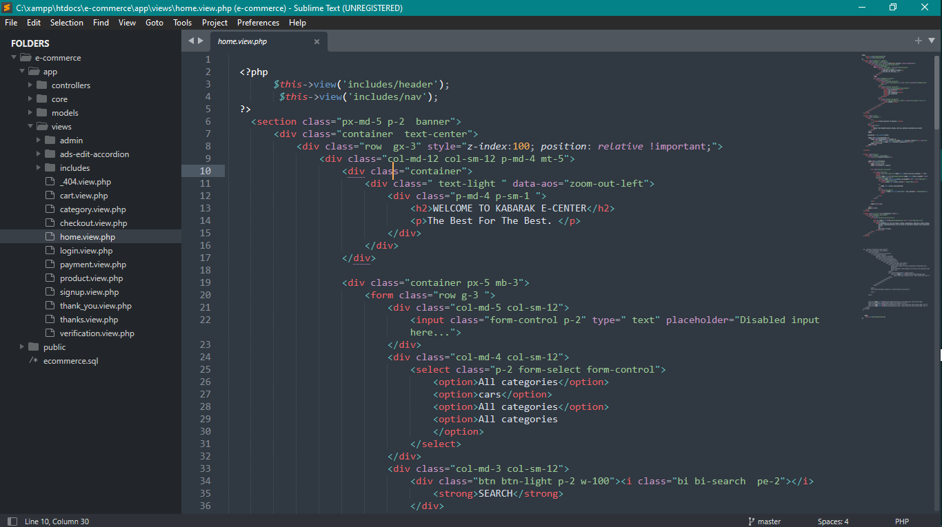

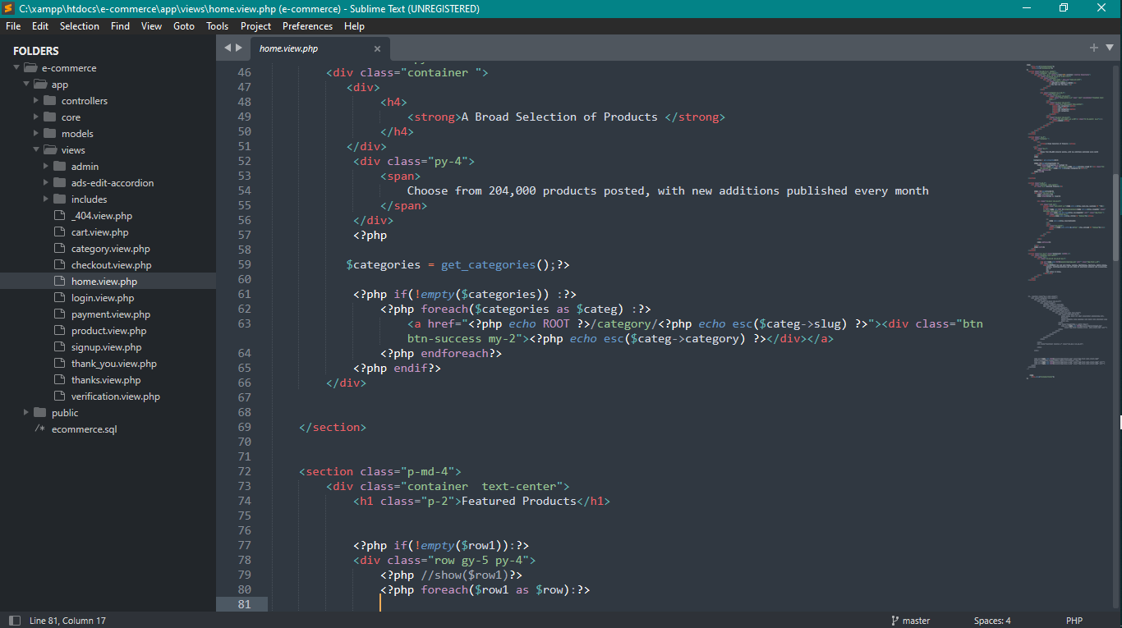

## 4.1.3 User Interface design

The User interface is user friendly and has easy to understand modules that do not require technical training to comprehend the operations and functioning.

## 4.1.4 Interface modules

Here is an image of the login page and the dashboard page of the proposed software.

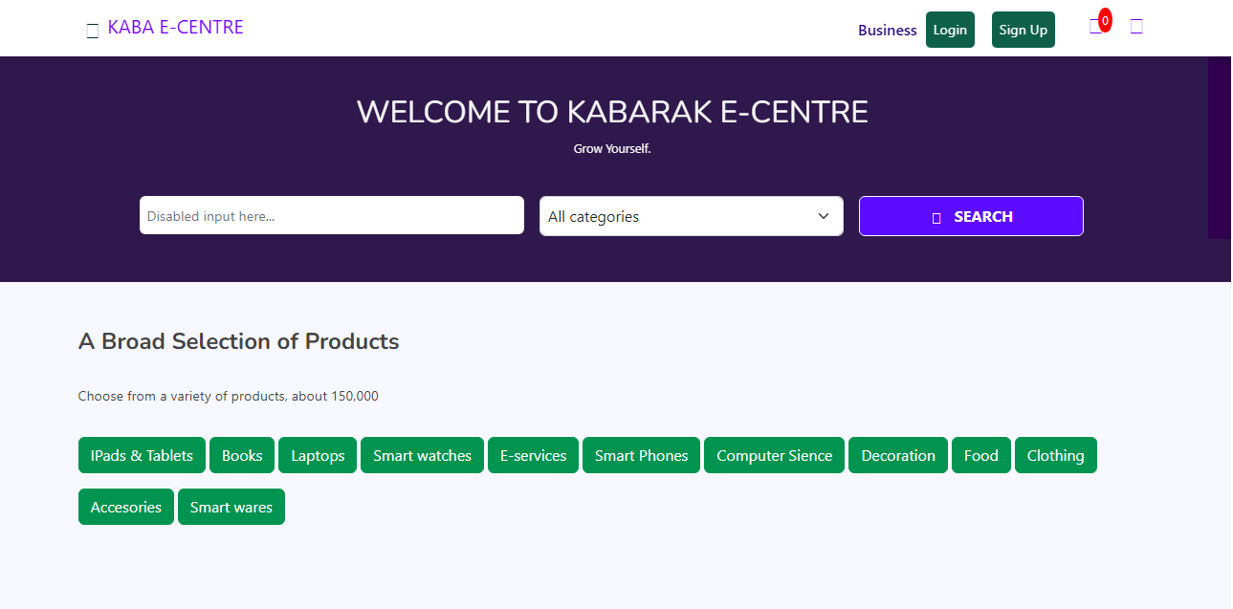

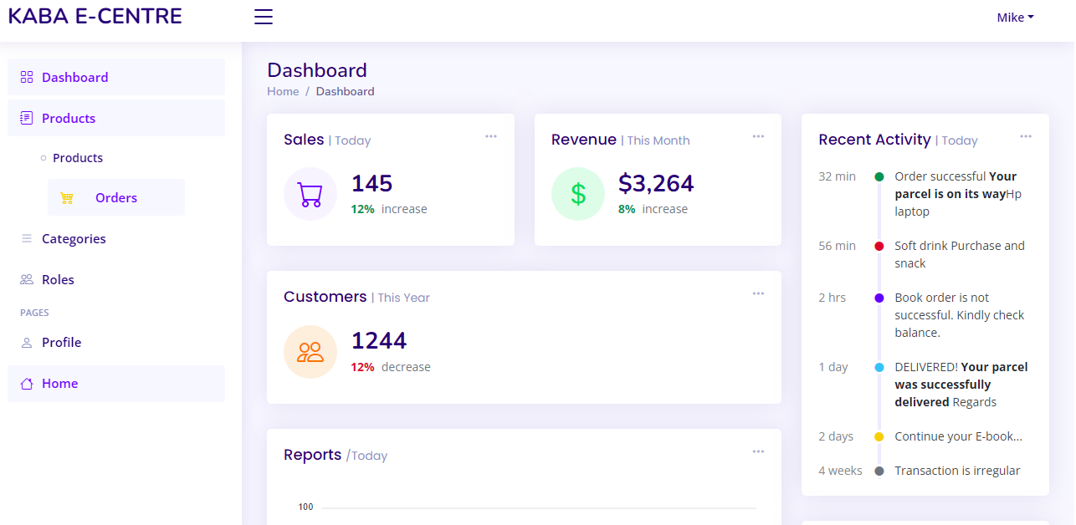

## 4.2 BACK-END DEVELOPMENT

The back-end development of the system carries the bulky part of the software. A database management system is vital and a web server. The DBMS of use is MySQL and web server is apache web server. The apache web server and MySQL are open source software that can be used in creating simple applications that require data handling and management.

Here’s an image of the apache web server control panel.

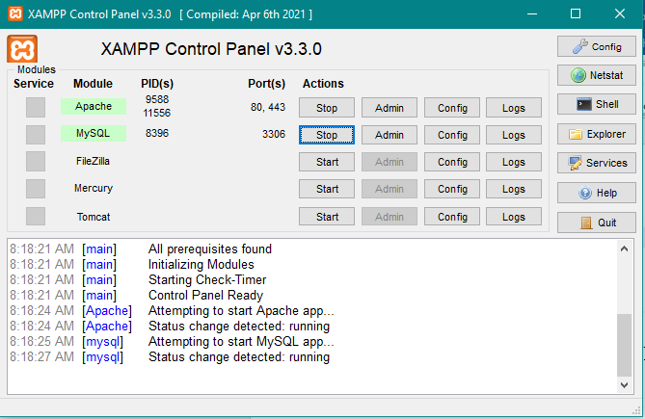

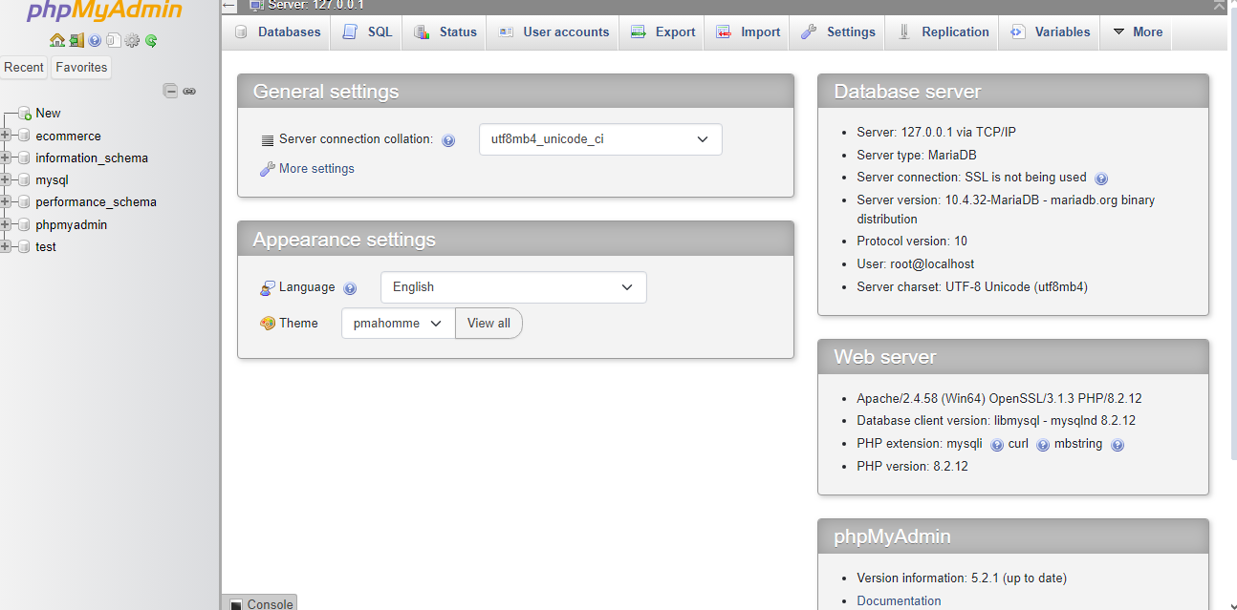

## 4.2.1 Database design

A database named hostel was created to facilitate the entry of student data and capture all necessary information. The database was coded on the MySQL terminal.

## 4.2.2 Database tables

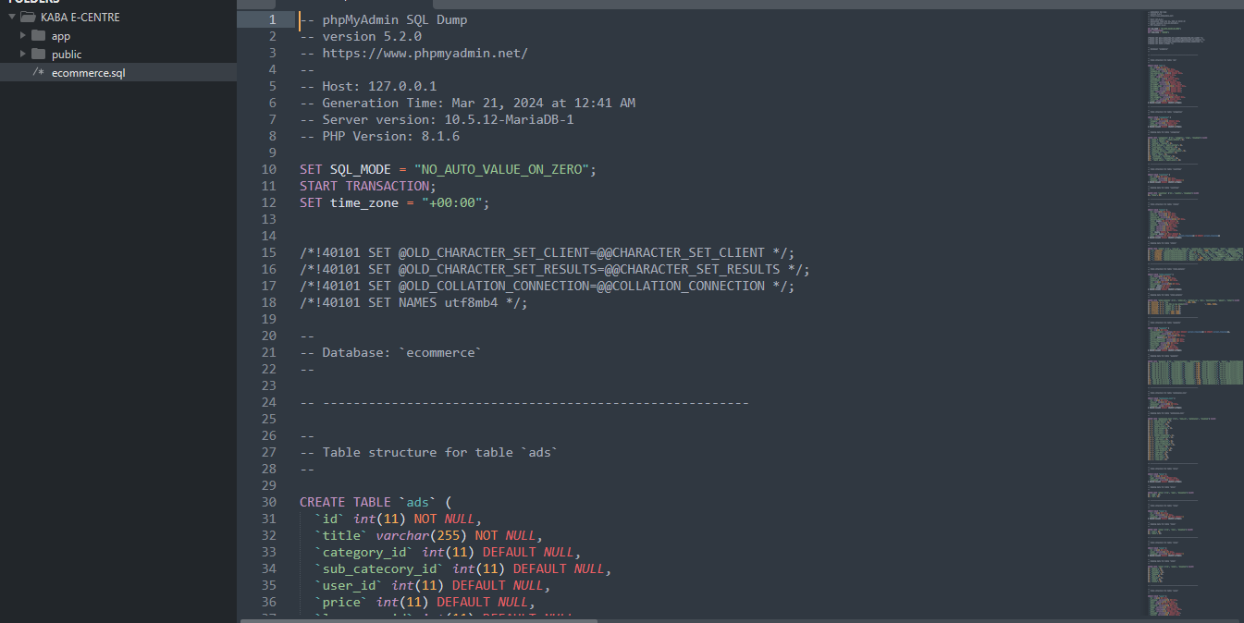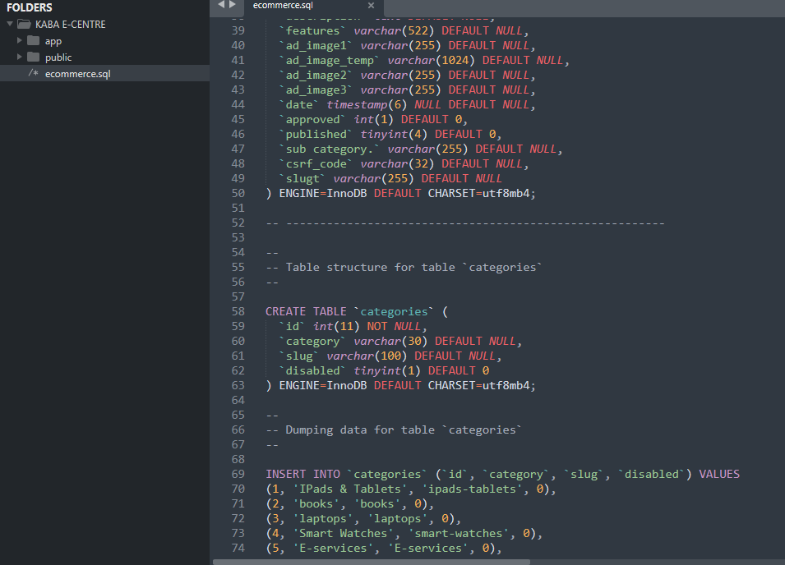

## 4.2.3 AUTHENTICATION SYSTEM.

The authentication module has two options. Finger-print verification and E-mail code verification. The finger-print module in this system is just for demonstration due to the lack of a finger-print reader device, however the e-mail verification is functioning and requires internet connection. Here is an image of the authentication page.

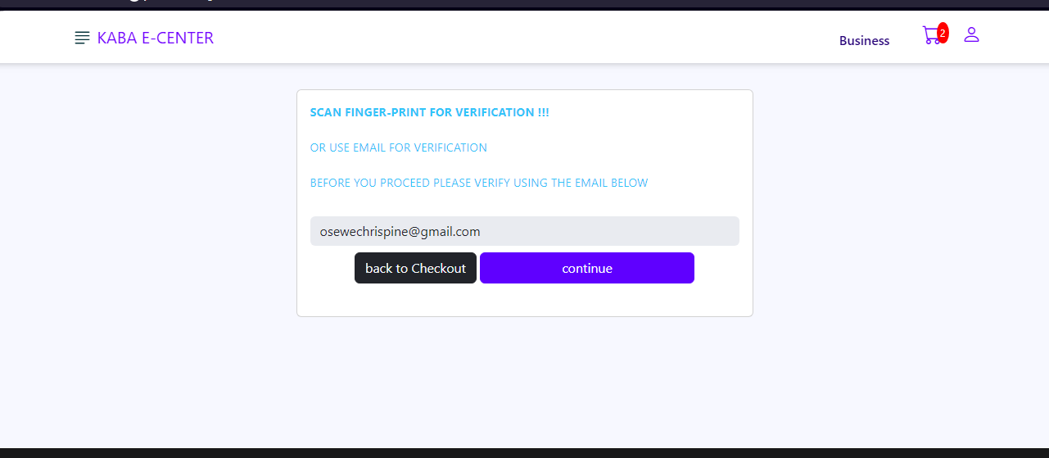

After e-mail verification the system proceeds to complete the transaction.



## 4.2.4 SYSTEM TESTING

Software testing is the process of analyzing a software item to detect the differences between existing and required conditions (that is, bugs) and to evaluate the features of the software item. This project will implement Black-box testing techniques to reach this objective.

Black-box testing is a method of software testing that examines the functionality of an application without peering into its internal structures or workings. Specific knowledge of the application's code/internal structure and programming knowledge in general is not required. The tester is aware of what the software is supposed to do but is not aware of how it does it. For instance, the tester is aware that a particular input returns a certain, invariable output but is not aware of how the software produces the output in the first place. (Patton, 2005).

The code is tested to ensure that the desired functionalities are working as required

*Advantages of Black Box Testing*

1. Tester can be non-technical.
2. Used to verify contradictions in actual system and the specifications.
3. Test cases can be designed as soon as the functional specifications are complete
4. Well suited and efficient for large code segments.

## 

## 4.3 CONCLUSION

The objective of this project was to develop an E-commerce system with biometric authentication features. The result allows the admin to monitor and control different movements within the hostel and the various rooms. The system has been demonstrated to be functioning by developing a simple system to control the various movements within the system.

## 

## 4.3.2 RECOMMENDATIONS

The nature of this project is such that it provides a great scope for further developments. This system can be improved and integrated into mobile applications that can allow remote account management.

APPENDICES

## APPENDIX A: Budget

|  |  |  |
| --- | --- | --- |
|  | Quantity | Amount |
| System software | 1 | 60,000 |
| Staff / student training | All affected | 10,000 |
|  | TOTAL | 70,000 |

## 

## APPENDIX B: Project schedule

|  |  |  |  |  |
| --- | --- | --- | --- | --- |
| ACTIVITY | September | October | November | December |
| Research |  |  |  |  |
| Software requirement collection |  |  |  |  |
| Software design and testing |  |  |  |  |
| implementation |  |  |  |  |
|  |  |  |  |  |

## 

## APPENDIX C: REFERENCES

* Connolly, T. M., & Begg, C. E. (2014). Database Systems: A Practical Approach to Design, Implementation, and Management. Pearson.
* Nielsen, J., & Budiu, R. (2013). Mobile Usability. New Riders.
* Tondreau, B. (2015). Layout Essentials: 100 Design Principles for Using Grids. Rockport Publishers.
* "Fingerprint Minutiae: A Review" by R. Cappelli, D. Maio, D. Maltoni, J. L. Wayman
* "Fingerprint Recognition: A Review" by Anil K. Jain, Arun Ross, and Salil Prabhaka
* "A Survey of Email Authentication Mechanisms" by K. S. P. J. Babu and T. Suresh Kumar
* "Sender Policy Framework (SPF) for Authorizing Use of Domains in Email, Version 1".